CSC 555: Mining Big Data

Project, Phase 2

In this part of the project, you will various queries using Hive, Pig and Hadoop streaming. The schema is available below, but don’t forget to apply the correct delimiter:

http://rasinsrv07.cstcis.cti.depaul.edu/CSC555/SSBM1/SSBM_schema_hive.sql

The data is available at:

http://rasinsrv07.cstcis.cti.depaul.edu/CSC553/data/ (this is Scale4)

<http://rasinsrv07.cstcis.cti.depaul.edu/CSC553/data/Scale14/>

In your submission, please note what instance and what cluster you are using (you can reuse your existing cluster for most of the questions). Please be sure to submit all code (pig, python and Hive). You should also submit the command lines you use and a screenshot of a completed run (just the last page, do not worry about capturing the whole output). An answer submission with screenshot/results but without the code will not receive credit.

I highly recommend creating a small sample input (e.g., by running head lineorder.tbl > lineorder.tbl.sample and testing your code with it, you can use head -n 100 to get first 100 lines).

**Part 1: Data Transformation**

Use Scale4 data to perform data processing, unless otherwise specified.

1. **Transform lineorder.tbl table into a comma-separated file: Use Hive, MapReduce with HadoopStreaming and Pig (i.e. 3 different solutions)**

**HIVE:**

cd $HIVE_HOME

bin/hive

If you need to restart Hive because you are unable to get into it. Run this command to clean all data. Be sure you are in apache-hive-2.01.1

stop-all.sh

rm -rf /tmp/hadoop-ec2-user/dfs/

go to each node by ssh “private IP Address” and run the same command

rm -rf /tmp/hadoop-ec2-user/dfs

then you format

hadoop namenode -format

Restart

start-dfs.sh

start-yarn.sh

mr-jobhistory-daemon.sh start historyserver

hadoop dfsadmin -report

Clear out hive (start fresh) – you will get an error when loading data into the table if you do not

rm -rf metastore_db/

$HIVE_HOME/bin/schematool -initSchema -dbType derby

hadoop dfsadmin -safemode leave

**Downloaded the file lineorder.tbl**

**Converted the large linorder.tbl file to smaller 100 row file called “lineorder.tbl.sample”**

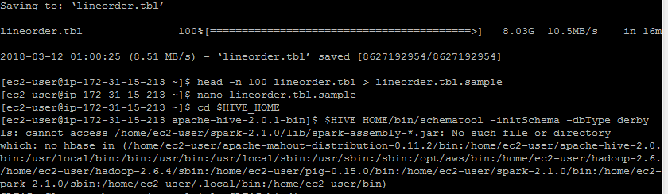

**Created table lineorder expecting input of ‘|’ delimited file**

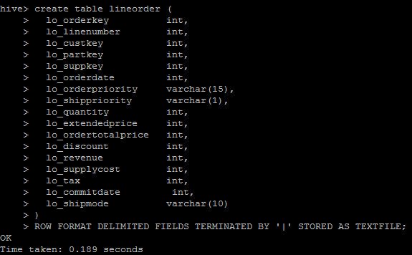

create table lineorder (

lo_orderkey int,

lo_linenumber int,

lo_custkey int,

lo_partkey int,

lo_suppkey int,

lo_orderdate int,

lo_orderpriority varchar(15),

lo_shippriority varchar(1),

lo_quantity int,

lo_extendedprice int,

lo_ordertotalprice int,

lo_discount int,

lo_revenue int,

lo_supplycost int,

lo_tax int,

lo_commitdate int,

lo_shipmode varchar(10)

)

ROW FORMAT DELIMITED FIELDS TERMINATED BY '|' STORED AS TEXTFILE;

**Loaded smaller file lineorder.tbl.sample file of 100 records into the table**

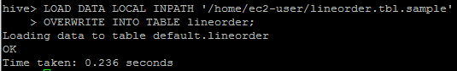

**LOAD DATA LOCAL INPATH '/home/ec2-user/lineorder.tbl.sample'**

**OVERWRITE INTO TABLE lineorder;**

**Using the smaller file lineorder.tbl.sample within the table linorder; exporting all contents of the table into a .csv file in HDFS user home directory labeled csv_line_order (/user/ec2-user/csv_line_order)**

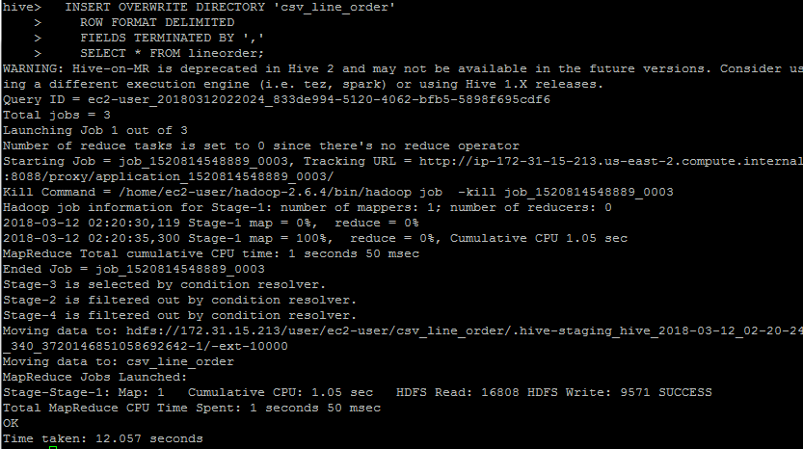

INSERT OVERWRITE DIRECTORY 'csv_line_order'

ROW FORMAT DELIMITED

FIELDS TERMINATED BY ','

SELECT * FROM lineorder;

hadoop fs –ls Command to see what files are located in HDFS

hadoop fs -ls csv_line_order Command to see what files are located in csv_line_order

hadoop fs -cat csv_line_order/000000_0 Command to see what the file looks like

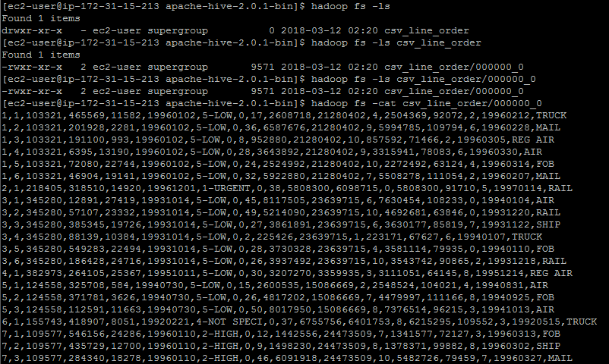

**ON A (5) NODE CLUSTER – LOAD THE LARGE FILE**

**Loaded entire file lineorder.tbl file of 100 records into the table**

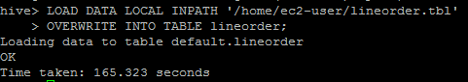

**LOAD DATA LOCAL INPATH '/home/ec2-user/lineorder.tbl'**

**OVERWRITE INTO TABLE lineorder;**

**Using the larger file lineorder.tbl within the table linorder; exporting all contents of the table into a .csv file in HDFS user home directory labeled csv_line_order_large (/user/ec2-user/csv_line_order_large)**

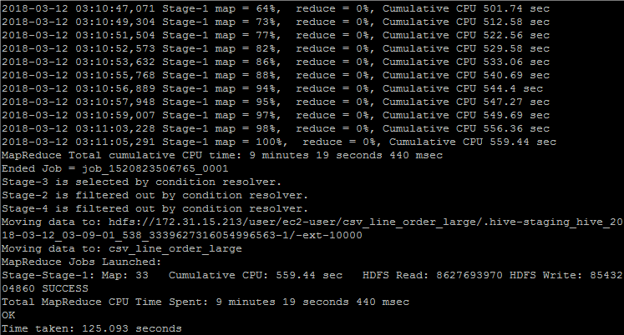

INSERT OVERWRITE DIRECTORY 'csv_line_order_large'

ROW FORMAT DELIMITED

FIELDS TERMINATED BY ','

SELECT * FROM lineorder;

hadoop fs -ls Command to see what files are located in HDFS

hadoop fs -ls csv_line_order_large Command to see what files are located in csv_line_order

hadoop fs -cat csv_line_order_large/000000_0 Command to see what the file looks like

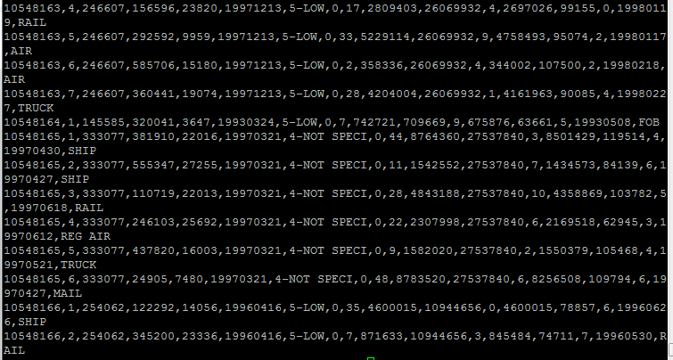

INSERT OVERWRITE DIRECTORY 'csv_line_order_large_singlenode'

ROW FORMAT DELIMITED

FIELDS TERMINATED BY ','

SELECT * FROM lineorder;

**B. Extract three of the numeric columns (lo_quantity, lo_linenumber, lo_revenue) for rows where lo_discount is between 6 and 8 into a space-separated text file (for K-Means clustering later). Use Hive, MapReduce with Hadoop Streaming, and Pig (3 different solutions)**

**Part 2: Querying**

All queries from SSBM benchmark are available here:

http://rasinsrv07.cstcis.cti.depaul.edu/CSC555/SSBM1/SSBM_queries_all.sql

Using Scale4 data perform the following data processing and don’t forget to time your results.

**HIVE**

**Download dwdate.tbl data**

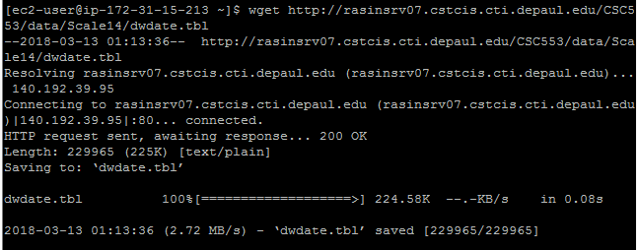

wget <http://rasinsrv07.cstcis.cti.depaul.edu/CSC553/data/Scale14/dwdate.tbl>

**Download part.tbl data**

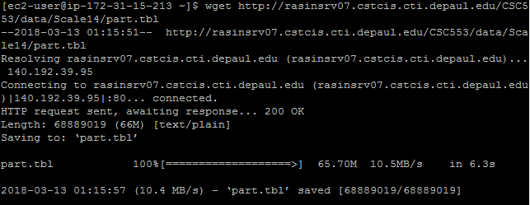

wget <http://rasinsrv07.cstcis.cti.depaul.edu/CSC553/data/Scale14/part.tbl>

**Download supplier.tbl data**

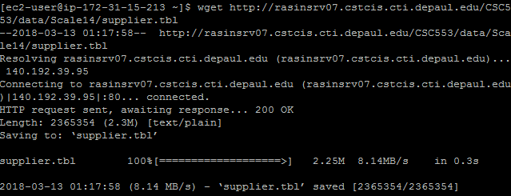

wget <http://rasinsrv07.cstcis.cti.depaul.edu/CSC553/data/Scale14/supplier.tbl>

**Download customer.tbl data**

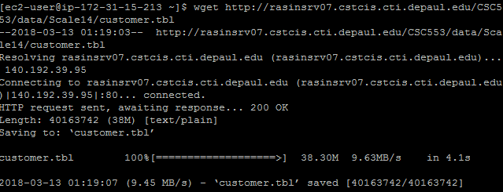

wget http://rasinsrv07.cstcis.cti.depaul.edu/CSC553/data/Scale14/customer.tbl

**Create Tables part, supplier, customer, dwdate**

create table part (

p_partkey int,

p_name varchar(22),

p_mfgr varchar(6),

p_category varchar(7),

p_brand1 varchar(9),

p_color varchar(11),

p_type varchar(25),

p_size int,

p_container varchar(10)

) ROW FORMAT DELIMITED FIELDS TERMINATED BY '|' STORED AS TEXTFILE;

create table supplier (

s_suppkey int,

s_name varchar(25),

s_address varchar(25),

s_city varchar(10),

s_nation varchar(15),

s_region varchar(12),

s_phone varchar(15)

) ROW FORMAT DELIMITED FIELDS TERMINATED BY '|' STORED AS TEXTFILE;

create table customer (

c_custkey int,

c_name varchar(25),

c_address varchar(25),

c_city varchar(10),

c_nation varchar(15),

c_region varchar(12),

c_phone varchar(15),

c_mktsegment varchar(10)

) ROW FORMAT DELIMITED FIELDS TERMINATED BY '|' STORED AS TEXTFILE;

create table dwdate (

d_datekey int,

d_date varchar(19),

d_dayofweek varchar(10),

d_month varchar(10),

d_year int,

d_yearmonthnum int,

d_yearmonth varchar(8),

d_daynuminweek int,

d_daynuminmonth int,

d_daynuminyear int,

d_monthnuminyear int,

d_weeknuminyear int,

d_sellingseason varchar(13),

d_lastdayinweekfl varchar(1),

d_lastdayinmonthfl varchar(1),

d_holidayfl varchar(1),

d_weekdayfl varchar(1)

) ROW FORMAT DELIMITED FIELDS TERMINATED BY '|' STORED AS TEXTFILE;

create table lineorder (

lo_orderkey int,

lo_linenumber int,

lo_custkey int,

lo_partkey int,

lo_suppkey int,

lo_orderdate int,

lo_orderpriority varchar(15),

lo_shippriority varchar(1),

lo_quantity int,

lo_extendedprice int,

lo_ordertotalprice int,

lo_discount int,

lo_revenue int,

lo_supplycost int,

lo_tax int,

lo_commitdate int,

lo_shipmode varchar(10)

) ROW FORMAT DELIMITED FIELDS TERMINATED BY '|' STORED AS TEXTFILE;

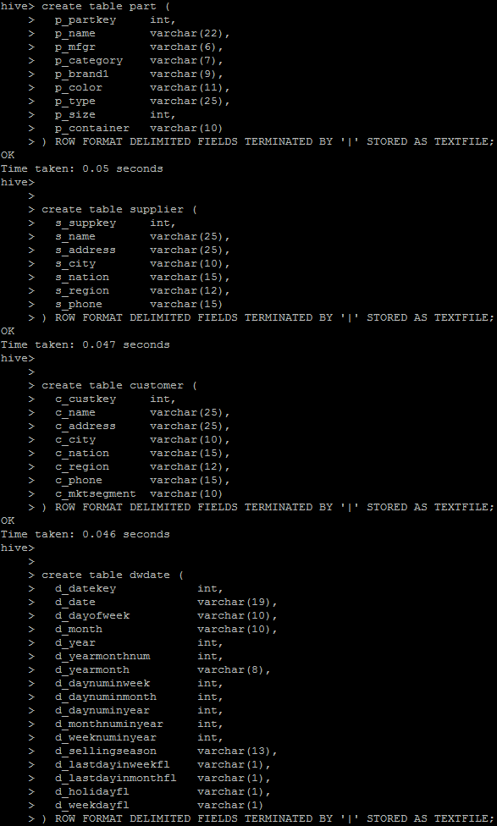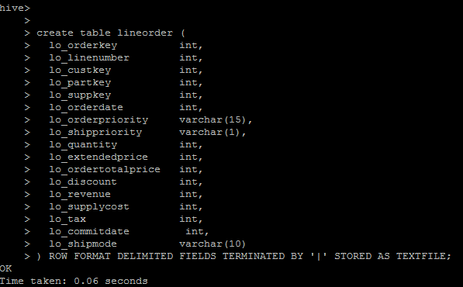

**Load customer.tbl data in customer table**

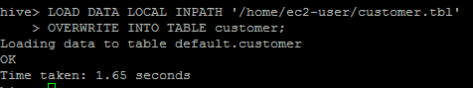

**LOAD DATA LOCAL INPATH '/home/ec2-user/customer.tbl'**

**OVERWRITE INTO TABLE customer;**

**Check to see if there is data**

**Select * FROM customer limit 5;**

**_____________________________________________________________________**

**Load part.tbl data in part table**

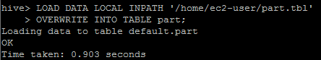

**LOAD DATA LOCAL INPATH '/home/ec2-user/part.tbl'**

**OVERWRITE INTO TABLE part;**

**Check to see if there is data**

**Select * FROM customer limit 5;**

**______________________________________________________________________**

**Load supplier.tbl data in supplier table**

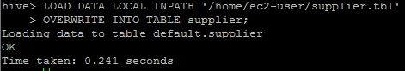

**LOAD DATA LOCAL INPATH '/home/ec2-user/supplier.tbl'**

**OVERWRITE INTO TABLE supplier;**

**Check to see if there is data**

**Select * FROM supplier limit 5;**

**_____________________________________________________________________**

**Load dwdate.tbl data in dwdate table**

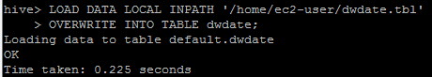

**LOAD DATA LOCAL INPATH '/home/ec2-user/dwdate.tbl'**

**OVERWRITE INTO TABLE dwdate;**

**Check to see if there is data**

**Select * FROM dwdate limit 5;**

**_____________________________________________________________________**

**Load lineorder.tbl data in lineorder table**

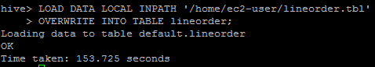

**LOAD DATA LOCAL INPATH '/home/ec2-user/lineorder.tbl'**

**OVERWRITE INTO TABLE lineorder;**

**Check to see if there is data**

**Select * FROM lineorder limit 5;**

**_____________________________________________________________________**

**PART 2 A: HIVE**

1. Run SSBM queries 2.1, 3.3 and 4.3 using Hive only (if you have issues running the queries, try placing lineorder table first in the FROM clause of the query)

http://rasinsrv07.cstcis.cti.depaul.edu/CSC555/SSBM1/SSBM_queries_all.sql

**Run Query 2.1**

--Q2.1 No simpifications

select sum(lo_revenue), d_year, p_brand1

from lineorder, dwdate, part, supplier

where lo_orderdate = d_datekey

and lo_partkey = p_partkey

and lo_suppkey = s_suppkey

and p_category = 'MFGR#12'

and s_region = 'AMERICA'

group by d_year, p_brand1

order by d_year, p_brand1;

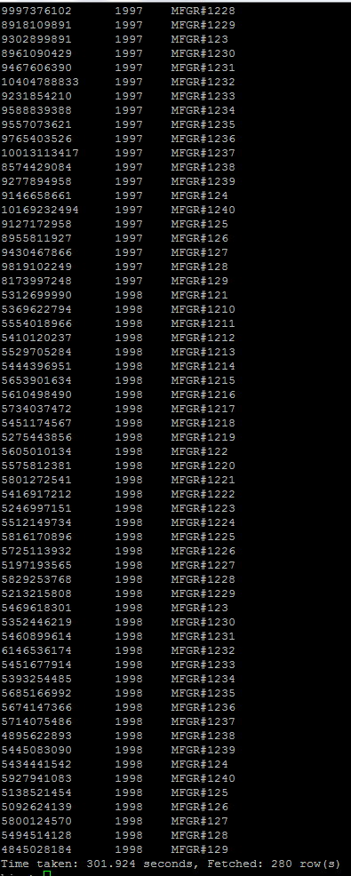

**Run Query 3.3**

select c_city, s_city, d_year, sum(lo_revenue) as revenue

from customer, lineorder, supplier, dwdate

where lo_custkey = c_custkey

and lo_suppkey = s_suppkey

and lo_orderdate = d_datekey

and c_nation = 'UNITED KINGDOM'

and c_city='UNITED KI1'

and s_city='UNITED KI1'

and s_nation = 'UNITED KINGDOM'

and d_year between 1992 and 1997

-- and d_year >= 1992 and d_year <= 1997

group by c_city, s_city, d_year

order by d_year asc, revenue asc;

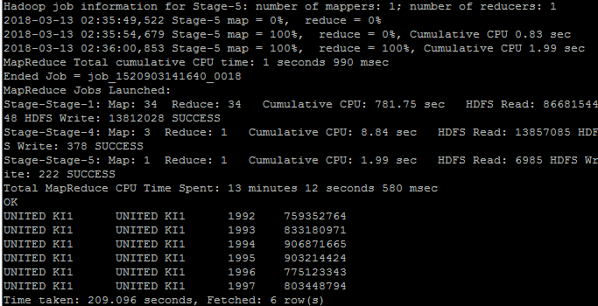

**Run Query 4.3**

select d_year, s_city, p_brand1, sum(lo_revenue) as profit1

from lineorder , dwdate, customer, supplier, part

where lo_custkey = c_custkey

and lo_suppkey = s_suppkey

and lo_partkey = p_partkey

and lo_orderdate = d_datekey

and c_region = 'AMERICA'

and s_nation = 'UNITED STATES'

and d_year = 1997

and p_category = 'MFGR#14'

group by d_year, s_city, p_brand1;

**WHY DID THIS QUERY ONLY WORK WHEN lineorder WAS IN THE BEGINNING? This confused me so much and I lost hours on it…. Please Please explain…**

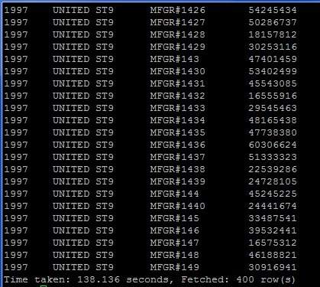

**PART 1 A: PIG - SMALL FILE**

cd $PIG_HOME

bin/pig

**To insure the file exists**

hadoop fs -mkdir /user/ec2-user

**To place the file where PIG can retrieve it**

hadoop fs -put ../lineorder.tbl.sample /user/ec2-user/

**To verify the file is there**

hadoop fs -ls /user/ec2-user/lineorder.tbl.sample

**Go back into PIG**

bin/pig

**Load the File**

lineordersmall = LOAD 'lineorder.tbl.sample' USING PigStorage('|') AS (lo_orderkey:int, lo_linenumber:int, lo_custkey:int, lo_partkey:int, lo_suppkey:int, lo_orderdate:int, lo_orderpriority:chararray, lo_shippriority:chararray, lo_quantity:int, lo_extendedprice:int, lo_ordertotalprice:int,lo_discount:int, lo_revenue:int, lo_supplycost:int, lo_tax:int, lo_commitdate:int, lo_shipmode:chararray);

**View the file**

Dump lineordersmall;

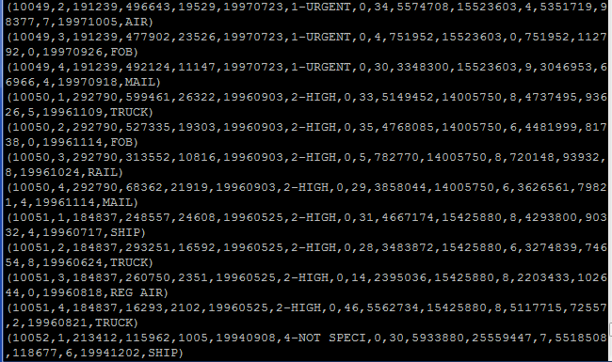

**To transform and store the file as a comma separated file**

Store lineordersmall INTO 'lineordersmall' USING PigStorage (',');

**To verify the file is there**

hadoop fs -ls /user/ec2-user/lineordersmall

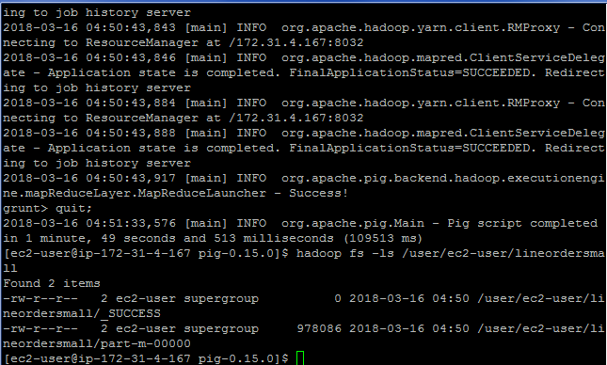

hadoop fs -cat lineordersmall/part-m-00000 Command to see what the file looks like

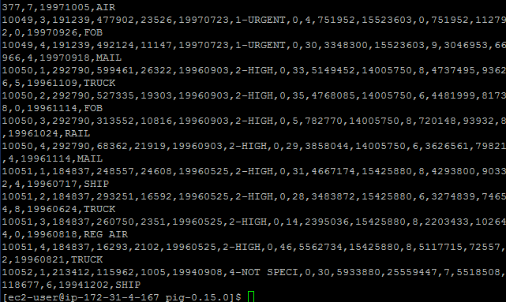

**PART 1 A: PIG - LARGE FILE**

**To insure the -mkdir file exists**

hadoop fs -mkdir /user/ec2-user

**To place the file where PIG can retrieve it**

hadoop fs -put ../lineorder.tbl /user/ec2-user/

**To verify the file is there**

hadoop fs -ls /user/ec2-user/lineorder.tbl

**Go back into PIG**

bin/pig

**Load the File**

lineorderlarge = LOAD 'lineorder.tbl' USING PigStorage('|') AS (lo_orderkey:int, lo_linenumber:int, lo_custkey:int, lo_partkey:int, lo_suppkey:int, lo_orderdate:int, lo_orderpriority:chararray, lo_shippriority:chararray, lo_quantity:int, lo_extendedprice:int, lo_ordertotalprice:int,lo_discount:int, lo_revenue:int, lo_supplycost:int, lo_tax:int, lo_commitdate:int, lo_shipmode:chararray);

**View the file (TOO LARGE TO DUMP)**

~~Dump lineorder.tbl;~~

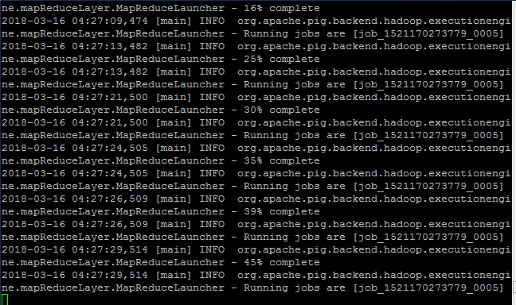

**To transform and store the file as a comma separated file**

Describe lineorderlarge; Store lineorderlarge INTO 'lineorderlarge2' USING PigStorage (',');



**To verify the file is there**

hadoop fs -ls /user/ec2-user/lineorderlarge **Note:** **There are 64 files that make up lineorder**

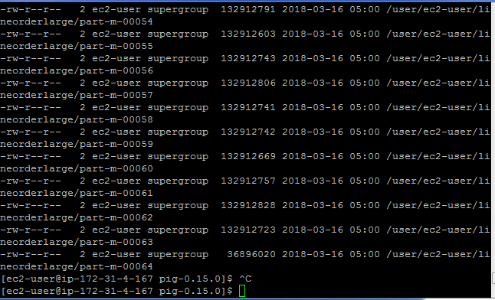

hadoop fs -cat lineorderlarge/part-m-00064 **Command to see what the file looks like (only pulled the last file)**

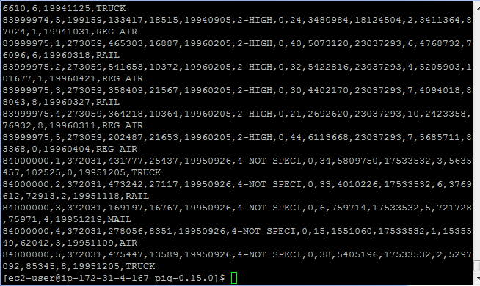

**PART 1 B: PIG – SMALL FILE**

cd $PIG_HOME

bin/pig

First = FILTER lineordersmall BY lo_discount > 6;

Second = FILTER First BY lo_discount < 8;

Third = FOREACH Second GENERATE lo_quantity, lo_linenumber, lo_revenue;

Dump Third;

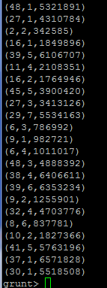

**To transform and store the file as a space separated file**

Store Third INTO 'Third_small' USING PigStorage (' ');

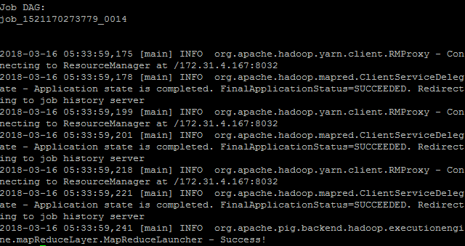

**To verify the file is there**

hadoop fs -ls /user/ec2-user/Third_small **Note:** **There is 1 that makes up Third_small**

hadoop fs -cat Third_small/part-m-00000 **Command to see what the file looks like**

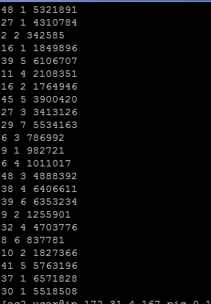

**PART 1 B: PIG – LARGE FILE**

cd $PIG_HOME

bin/pig

First_large = FILTER lineorderlarge BY lo_discount > 6;

Second_large = FILTER First_large BY lo_discount < 8;

Third_large = FOREACH Second_large GENERATE lo_quantity, lo_linenumber, lo_revenue;

T = LIMIT Third_large 10;

Describe T; Dump T;

**To transform and store the file as a space separated file**

Describe Third_large; Store Third_large INTO 'PART1_B_PIG' USING PigStorage (' ');

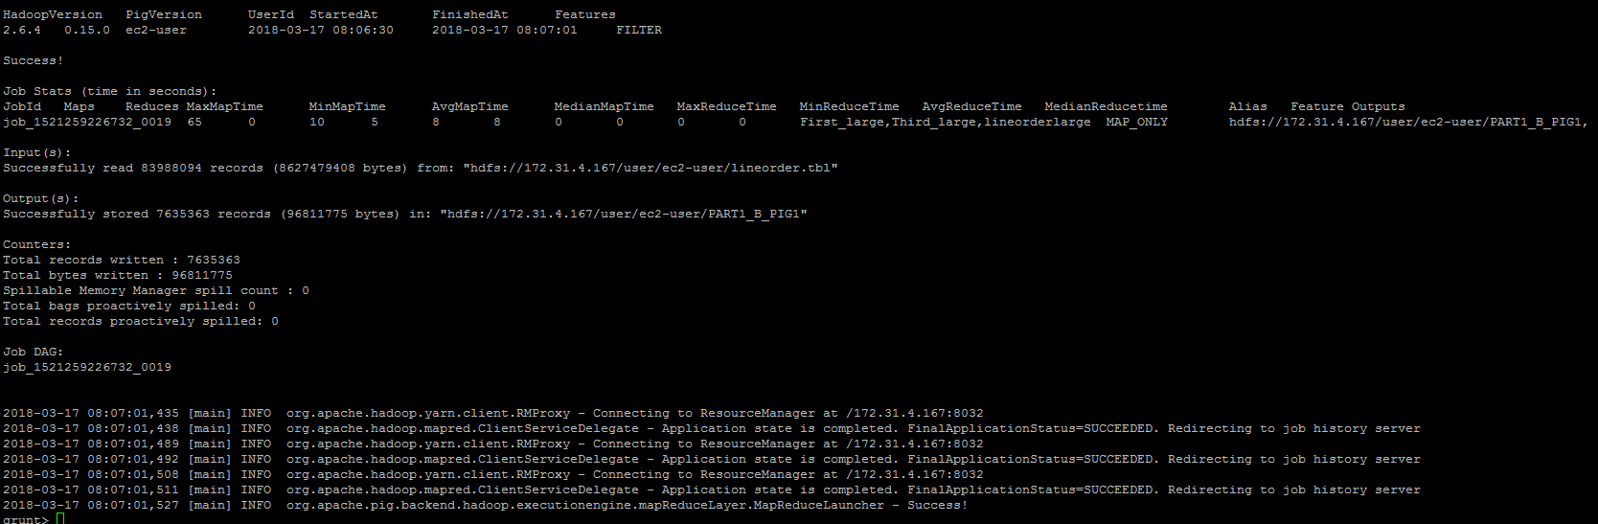

**To verify the file is there (leave pig first)**

hadoop fs -ls /user/ec2-user/PART1_B_PIG **Note:** **There are 64 files that make up Third_large**

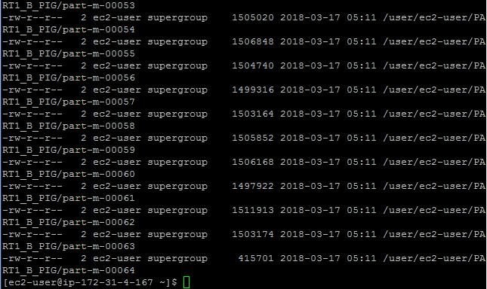

hadoop fs -cat /user/ec2-user/PART1_B_PIG/part-m-00064 **Command to see what the file looks like**

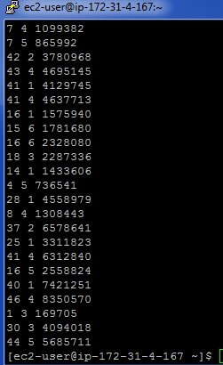

**PART 1 A: Hadoop Streaming**

**PART 1 B: HIVE**

cd $PIG_HOME

bin/pig

INSERT OVERWRITE DIRECTORY 'Part_1_B'

ROW FORMAT DELIMITED

FIELDS TERMINATED BY ' '

SELECT lo_quantity, lo_linenumber, lo_revenue FROM lineorder WHERE lo_discount BETWEEN 6 and 8;

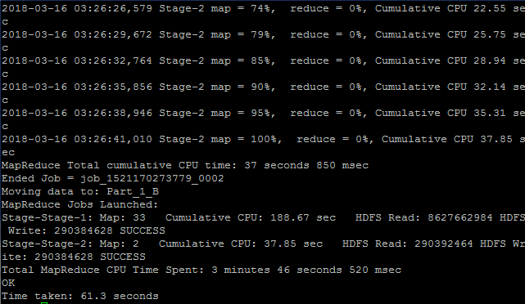

hadoop fs -ls Command to see what files are located in HDFS

hadoop fs -ls Part_1_B Command to see what files are located in csv_line_order

hadoop fs -cat Part_1_B/000001_0 Command to see what the file looks like

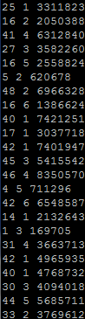

**/home/ec2-user/**

**Transform lineorder to comma deliminated**

LineorderCSV = lineordersmall;

**Load customer.tbl**

customer = LOAD 'customer.tbl' USING PigStorage('|') AS (customerID:chararray, code:chararray, Country:chararray, Country1:chararray, SSN:charrarray, type:chararray);

**Load date.tbl**

Date = LOAD 'data.tbl' USING PigStorage('|') AS (DateID:int, Date:chararray, DOW:chararray, Month: chararray, YEAR:int, YYYYMM:int, MonYYYY:chararray, DayNo:int, num1:int, num2:int, num3:int, num4:int, season: chararray, num5:int, num6:int, num7:int, num8:int);

**PART 2 B: HIVE**

Create a pre-join (i.e. a new data file) that corresponds to the following query below. You can think of it as a materialized view. What is the size of the new file? Use Hive and Pig (2 different solutions and be sure to report the file size for both).

SELECT lo_partkey, lo_suppkey, s_suppkey, d_year, lo_revenue

FROM lineorder, dwdate, lo_supplier WHERE lo_orderdate = d_datekey and lo_suppkey = s_suppkey;

INSERT OVERWRITE DIRECTORY 'PART2_B_HIVE'

ROW FORMAT DELIMITED

FIELDS TERMINATED BY '\t'

SELECT lo_partkey, lo_suppkey, s_suppkey, d_year, lo_revenue

FROM lineorder, dwdate, supplier WHERE lo_orderdate = d_datekey and lo_suppkey = s_suppkey;

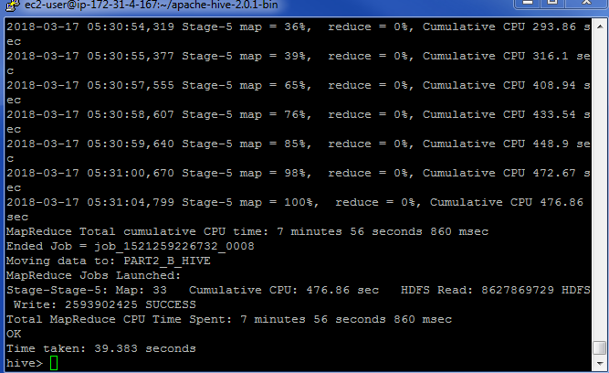

hadoop fs -ls Command to see what files are located in HDFS

hadoop fs -ls PART2_B_HIVE

Command to see what files are located in PART2_B_HIVE and how large the files are (33 Files)

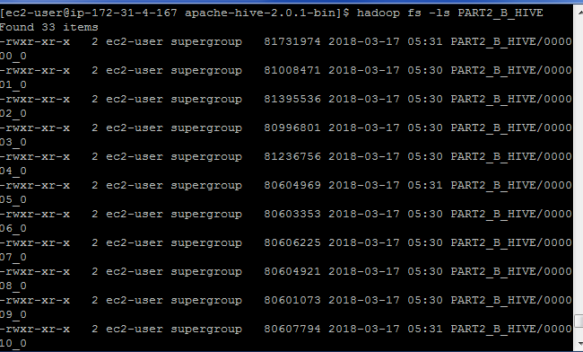

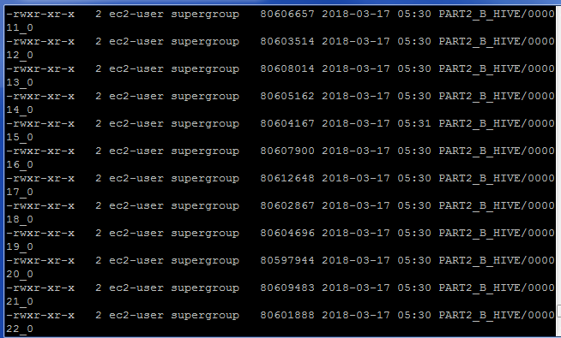

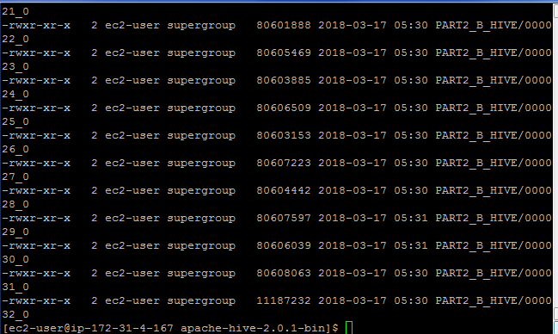

Complete file(s) sizes total = 2,674,504,313

hadoop fs -cat PART2_B_HIVE/000032_0 Command to see what the file looks like (file 32)

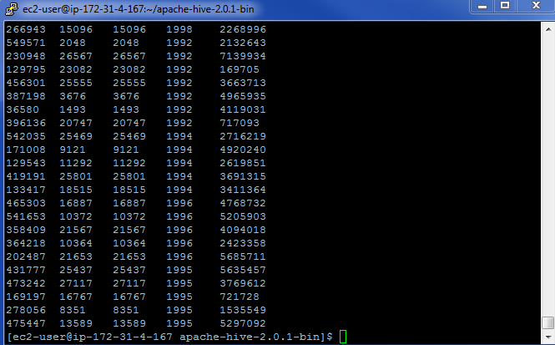

**PART 2 B: PIG**

Create a pre-join (i.e. a new data file) that corresponds to the following query below. You can think of it as a materialized view. What is the size of the new file? Use Hive and Pig (2 different solutions and be sure to report the file size for both).

SELECT lo_partkey, lo_suppkey, s_suppkey, d_year, lo_revenue

FROM lineorder, dwdate, lo_supplier WHERE lo_orderdate = d_datekey and lo_suppkey = s_suppkey;

INSERT OVERWRITE DIRECTORY 'hive_pre-join_file'

ROW FORMAT DELIMITED

FIELDS TERMINATED BY ','

SELECT lo_partkey, lo_suppkey, s_suppkey, d_year, lo_revenue

FROM lineorder, dwdate, supplier

WHERE lo_orderdate = d_datekey and lo_suppkey = s_suppkey;

cd $PIG_HOME

bin/pig

**To insure the -mkdir file exists**

hadoop fs -mkdir /user/ec2-user

**To place the lineorder file where PIG can retrieve it**

hadoop fs -put ../lineorder.tbl /user/ec2-user/

**To place the dwdate file where PIG can retrieve it**

hadoop fs -put ../dwdate.tbl /user/ec2-user/

**To place the supplier file where PIG can retrieve it**

hadoop fs -put ../supplier.tbl /user/ec2-user/

**To verify the lineorder file is there**

hadoop fs -ls /user/ec2-user/lineorder.tbl

**To verify the dwdate file is there**

hadoop fs -ls /user/ec2-user/dwdate.tbl

**To verify the supplier file is there**

hadoop fs -ls /user/ec2-user/supplier.tbl

**Go back into PIG**

bin/pig

**Load the lineorder File**

lineorderlarge = LOAD 'lineorder.tbl' USING PigStorage('|') AS (lo_orderkey:int, lo_linenumber:int, lo_custkey:int, lo_partkey:int, lo_suppkey:int, lo_orderdate:int, lo_orderpriority:chararray, lo_shippriority:chararray, lo_quantity:int, lo_extendedprice:int, lo_ordertotalprice:int,lo_discount:int, lo_revenue:int, lo_supplycost:int, lo_tax:int, lo_commitdate:int, lo_shipmode:chararray);

X = LIMIT lineorderlarge 10;

DUMP X;

**Load the dwdate File**

dwdatelarge = LOAD 'dwdate.tbl' USING PigStorage('|') AS (d_datekey:int, d_date:chararray, d_dayofweek:chararray, d_month:chararray, d_year:int, d_yearmonthnum:int, d_yearmonth:chararray, d_daynuminweek:int, d_numinmonth:int, d_daynuminyear:int, d_weeknuminyear:int,

Y = LIMIT dwdatelarge 10;

DUMP Y;

d_sellingseason:chararray, d_lastdayinweekfl:chararray, d_lastdayinmonthfl:chararray, d_holidayfl:chararray, d_weekdayfl:chararray);

**Load the supplier File**

supplierlarge = LOAD 'supplier.tbl' USING PigStorage('|') AS (s_suppkey:int, s_name:chararray, s_address:chararray, s_city:chararray, s_nation:chararray, s_region:chararray, s_phone:chararray);

Z = LIMIT supplierlarge 10;

DUMP Z;

**Create the Join, Verify it works by only outputting 10 columns**

A = JOIN lineorderlarge BY lo_orderdate, dwdatelarge BY d_datekey;

B = JOIN A BY lo_suppkey, supplierlarge BY s_suppkey;

C = FOREACH B GENERATE lo_partkey, lo_suppkey, d_year, lo_revenue;

D = LIMIT C 10;

Describe D; Dump D;

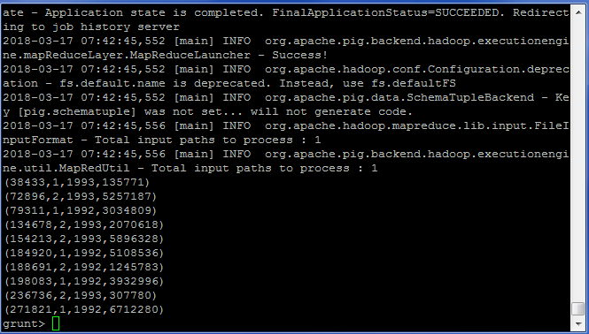

Describe C; Store C INTO 'PART2_B_PIG' USING PigStorage ('\t');

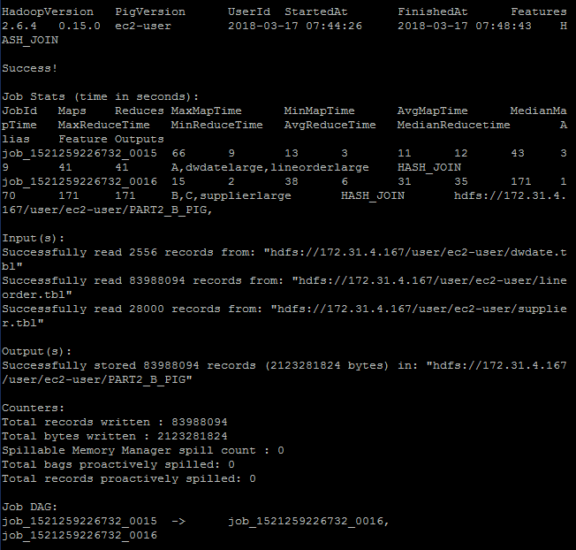

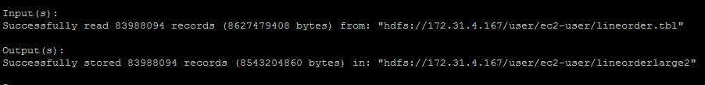

**Part 3: Clustering**

Using the file you have created in 1-B, run KMeans clustering using 11 clusters.

A. Using Mahout synthetic clustering as you have in a previous assignment on sample data. This entrails running the same clustering command, but substituting your own input data instead of the sample.

**NOTE:** if you get a java.lang.OutOfMemoryError error, you will need to reconfigure Hadoop to supply the java virtual machine with more memory. You can do this by editing the mapred-site.xml (Mapper should not need much RAM):

*<property>*

*<name> mapreduce.reduce.java.opts</name>*

*<value>-Xmx1024m</value>*

*</property>*

The amount of memory can be tweaked (you can go higher, but keep in mind how much physical memory your machine has). If you **still** run out of memory in 3-A submit the screenshot of that change and you will get full credit for the question.

In order to change directory to mahout use

cd /home/ec2-user/apache-mahout-distribution-0.11.2/

Create Part3_A directory in HDFS

hadoop fs -mkdir -p testdata

Inspect the file created in Part2 B from above.

hadoop fs -cat PART2_B_HIVE/000032_0

Copy the file into Part3_A

~~hadoop fs -put /user/ec2-user/PART2_B_HIVE/000032_0 testdata/~~

hadoop fs -put /PART2_B_HIVE/000032_0 testdata/

time mahout org.apache.mahout.clustering./user/ec2-user/PART2_B_HIVE/000032_0.kmeans.Job

(clusterdump is a built-in Mahout command that will produce the result of KMeans. Output file is written to clusters-10-final because that is where the output is written after 10 iterations. The center points are placed in a separate file, called clusteredPoints)

mahout clusterdump --input output/clusters-10-final --pointsDir output/clusteredPoints –output clusteranalyze.txt

The file clusteranalyze.txt contains the results of the Kmeans run after 10 iterations

B. Using Hadoop streaming perform three iterations manually (initially with randomly chosen centers). This would require passing a text file with cluster centers using -file option, opening the centers.txt in the mapper with open(‘centers.txt’, ‘r’) and assigning a key to each point based on which center is the closest to each particular point. Your reducer would then compute the new centers, and at that point the iteration is done and the output of the reducer can be given to the next pass.

**NOTE**: Not attempting to answer this question will result in an additional grade penalty

**Part 4: Performance**

Compare the performance given following combinations.

**A. All three of your solutions to Part-1A with**

**a. Scale4: a single node cluster and a cluster of at least 4 nodes**

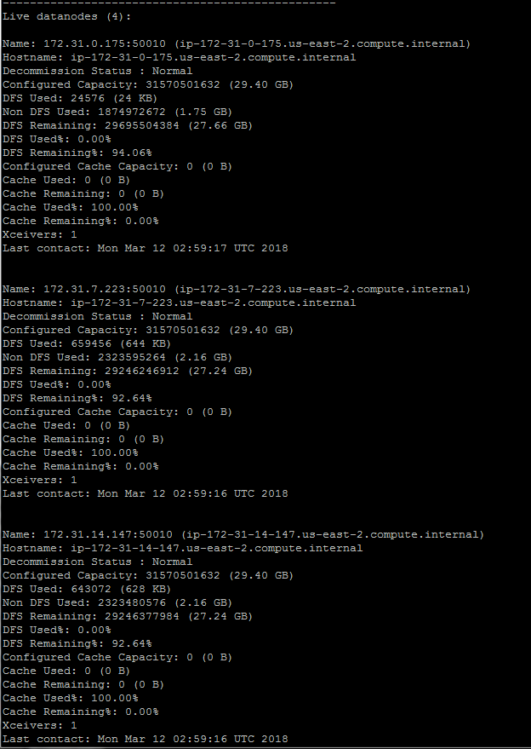

|  |  |  |  |  |  |  |
| --- | --- | --- | --- | --- | --- | --- |
|  | HIVE | | PIG | | Hadoop-Streaming | |
|  | 5-Node | Single-Node | 5-Node | Single-Node | 5-Node | Single-Node |
| Part1-A | 2:05 |  | 1:07 |  |  |  |
| Part2-B | :39 |  | 4:17 |  |  |  |
|  |  |  |  |  |  |  |
|  |  |  |  |  |  |  |
|  |  |  |  |  |  |  |

B. Both of your solutions for 2-B.

a. Scale4: a single node and a cluster of at least 4 nodes

C. Summarize the results and cluster performance/scaling in at least a paragraph.

**Extra Credit**

Research and describe the most affordable way to build a 10-Petabyte drive. The drive should be built to own, not to rent (Dropbox or similar services doesn’t count, even if it does say “unlimited” storage).

Submit a single document containing your written answers. Be sure that this document contains your name and “CSC 555 Project Phase 2” at the top.